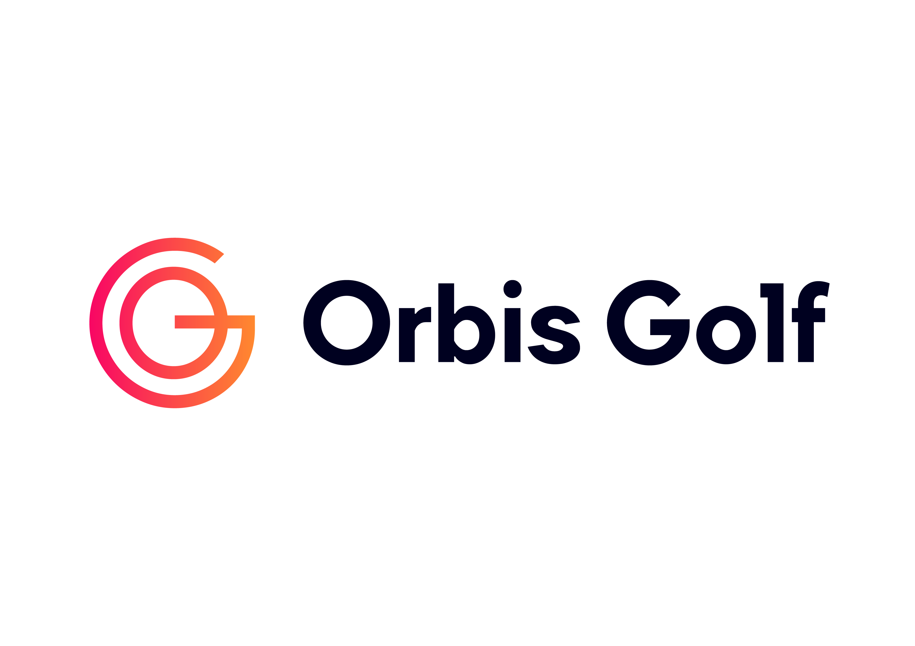

Subject: Upcoming [Masterclass Name Here] Event

Dear [insert participant’s name],

Thank you for signing up to the [Masterclass Name Here] Masterclass Event. This event is designed to provide you with an opportunity to develop your skills and will allow you to meet others at the club with similar experience, abilities and aspirations.

You will have received a confirmation of your booking onto the program through GLF. Connect, however I just wanted to share some of the most important information prior to the event:

Date and Timings

- The dates and start time of the event is [Insert Date & Time]. The event will run for [Insert Duration] and will therefore finish at [Insert End Time].

Where we will Meet

- We will meet at [insert meeting point] and it would be great if you could arrive at least 10 minutes prior to the start time.

What to Bring

- Golf clubs if you have your own. If you need to borrow clubs please let us know as soon as possible so that we can arrange them.
- Water bottle
- Sunscreen if appropriate

What to Wear

- There is no dress code as such but please be aware that we will be outside, and our games and activities will require active participation. Please dress appropriately.
- Trainers are the best footwear if you don’t have golf shoes.

Hopefully that covers everything you need to know. If you have any questions please don’t hesitate to contact me, I look forward to seeing you at the club soon.

Many thanks,

[Insert Coach Name]
© 2023 Powered by Orbis Golf

